How To Use This Guide:

Below is a list of suggested resources to lead your small group. They are categorized by Bible studies (those that focus more on specific books, chapters, etc.), guys (those written targeting boys), girls (those written targeting ladies), and various (basically everything else). The first page includes a list of all the suggested books and studies with a page number telling you where a description of them is listed in this guide. Then further on is the guide with the descriptions. There are a ton of really good options to choose from, so I wanted to point out a few important things to consider when choosing what might work for you.
- Length of time: some of these studies are for 8 weeks, some are for only 4 or 5. Now the good news is you can decide how fast you go through it – if you actually do 1 week per week, or if you break it up into more to fit your time table – but think ahead on that.
- What your audience needs: while we tried to keep these suggestions relevant to your audience, knowing your specific small group may be helpful to determining what fits them and meets their needs in what season they are going through
- What you are passionate about: just like a student learns so much more from a teacher who’s passionate about what they’re teaching, you can teach based off what you’re passionate about too! If you love prayer, go through a book on prayer; if you love Proverbs, teach on that. Your passion will speak through your teaching sometimes louder than the specific words you say.
- Pray: don’t be afraid to go to the Lord when you don’t have the answers. He will help you, He will sustain you, and He will speak through you as you pour into these kids’ lives. Give Him room to work, and He will. Ask Him to be the One changing their hearts and lives, and He will.
- Ask for help when you need it!: we on the Fuse team are here for you! Don’t feel like you have to walk this alone. The Lord created us as a body to continue to support one another and grow together. Whether one of your students is going through something or you are, whether you need to buy something for your students like their small group materials or a Bible, don’t hesitate to ask! We’re here for you, to support you and walk with you through this adventure of pouring into high schoolers together!

Bible Studies
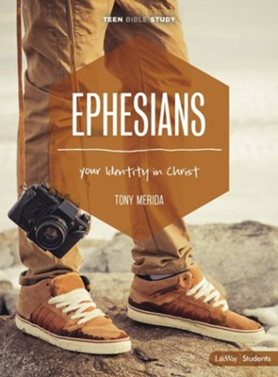
Ephesians: Your Identity in Christ, Teen Bible Study, Tony Merida - Biblically rooted and gospel-centered, Ephesians - Teen Bible Study Student Book is a six-session study by Tony Merida, offering practical answers to basic questions about the Christian life and our identity in Christ.
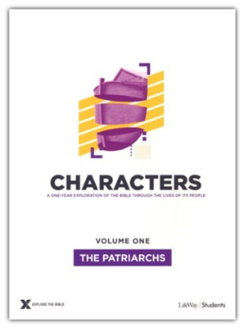
ETB Characters (7 volumes): Teen Study Guide – The highs and lows of Biblical charterers will help students see how God wants to shape them and use them for His glory and the good of the world—no matter who they are!
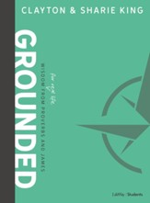
Grounded: Wisdom for real life from Proverbs and James, Clayton and Sharie King - Over the course of eight sessions (10-12 mins. each), Clayton and Sharie King will guide students to a holistic understanding of biblical wisdom.

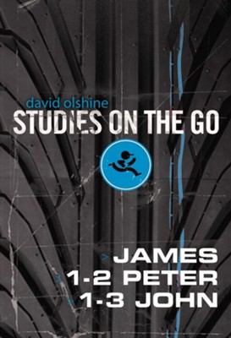
Studies on the Go: James, 1-2 Peter, and 1-3 John, David Olshine – The purpose of this book in the Studies On the Go series is to provide small group leaders with creative and engaging Bible study questions they won’t have to rewrite. Students will be pushed, encouraged, and challenged, but the real goal is that they would be changed.

Guys
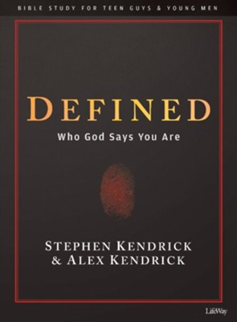
Defined, Stephen and Alex Kendrick - This 8-session Bible Study for teen guys and young men, Defined: Who God Says You Are, examines spiritual truths from the Book of Ephesians in order to lead young men into a closer relationship with God and a better understanding and appreciation of their God-given identity

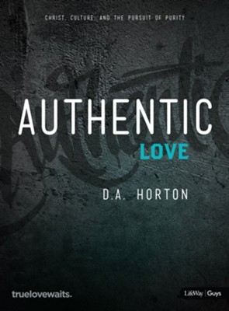
Authentic Love – Bible Study for Guys: Christ, Culture, and the Pursuit of Purity, D.A. Horton - Speaking directly to the hearts of guys, Authentic Love Bible Study for Guys exposes culture's distorted messages about purity and love and reveals how God has created us for a lifestyle of personal holiness. Over the course of 8 sessions, students will examine five attributes of holiness that shape their identity
Girls

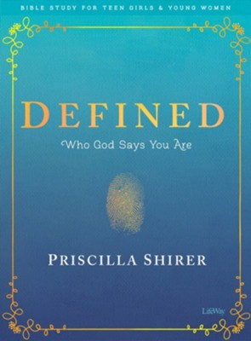
Defined, Priscilla Shirer - This 8-session Bible Study for teen girls and young women, Defined: Who God Says You Are, helps young women understand who God is and what it means to be created in His image so they can start walking in their true identities as a daughter of the most high King.
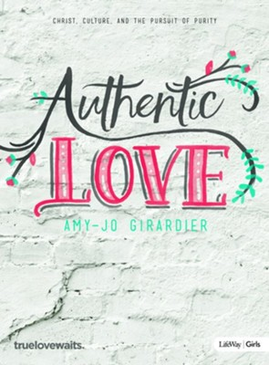
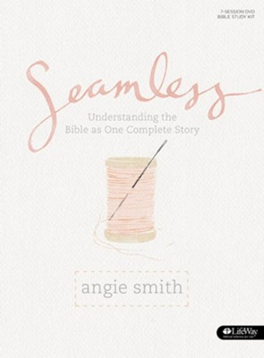
Authentic Love – Bible Study for Girls: Christ, Culture, and the Pursuit of Purity, Amy-Jo Girardier - Over the course of 8 sessions, students will examine five attributes of holiness that shape their identity. They will be challenged to reject the self-serving influences of culture and embrace what it means to live as godly young women who reflect the character of Christ.
Seamless: Understanding the Bible as One Complete Story, Angie Smith - Written for teen girls, the Seamless Bible Study Leader Kit covers the people, places, and promises of the Bible, showing them how the entire Bible. Each of the seven weeks of study explore the overarching themes of Scripture and how God's love and grace are woven together as one seamless thread.

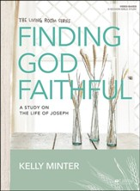
Finding God Faithful: A study on the life of Joseph, Kelly Minter – (girls) No doubt there have been, or will be, times in your life when your circumstances lead you to wonder if God is there, if He cares, and if things are slipping out of His control. Surely similar thoughts ran through Joseph’s mind as he suffered through betrayal, false accusations, and imprisonment. But throughout his story, we are constantly reminded of God’s faithfulness.
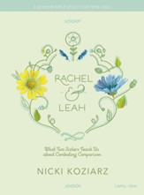
Rachel and Leah, Teen Girls’ Bible Study, Nicki Koziarz - Over the course of six sessions, author Nicki Koziarz will help girls take an honest look at themselves and allow God's truth to combat the comparison they struggle against. God calls girls to trust Him to lead their steps so that they might walk in the fullness of who He created them to be.

Various Topics for Guys or Girls
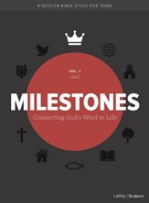
Milestones: Connecting God’s Word to Life - The Milestones Series, designed for teens, is a 6-volume Bible Study series covering the basic doctrines of the Christian faith. Each study consists of eight sessions and can be completed in a variety of settings including a small teen Bible Study group, Sunday School, or Youth Group.
Life Choices - This five-week study will help teens deal with issues like peer pressure, divorce, and self-injury. The weekly sessions encourage interaction and discussion between group members and include weekly discussion questions and daily devotions. Every group member will need a Student Guide.
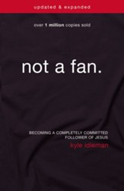
Not a Fan: What does it really mean to follow Jesus?, Kyle Idleman - How would you define your relationship with Jesus? Are you truly his follower or just a fan? Using humor, personal stories, and biblical truth, Idleman challenges students to look at what it means to call themselves Christians and follow Jesus' radical call.
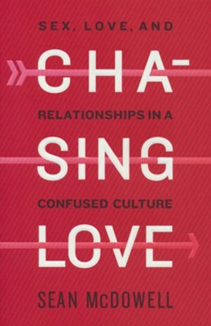
Chasing Love, Sean McDowell - In this nine-session Bible study, Sean McDowell takes us through God’s Word to answer some of our toughest questions about love, sex, gender, and relationships.
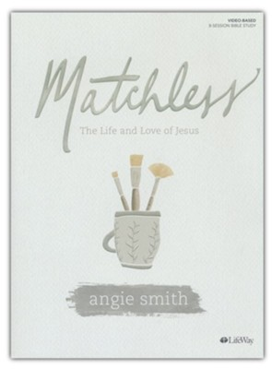
Matchless: The Life and Love of Jesus, Angie Smith - Join Seamless author Angie Smith in this 8-session search for truth as she unfolds the story of our matchless Savior—His mission, miracles, and message.

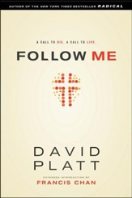
Follow Me, David Platt - The Follow Me Student Bible Study, based on David Platt's book Follow Me, is a short-term, video-enhanced study for all youth, grades 7 to 12. "Follow Me." Christ's command has been examined time and again, but have we lost sight of its meaning? This study will guide students to an understanding of Jesus' call to deny self and live with an unwavering devotion to Him
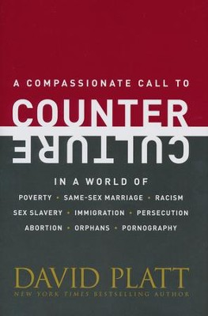
Counter Culture, David Platt - The gospel compels us to stand firm on the truth of God's Word and approach every issue with compassion and grace. This 6-session video-enhanced Bible study will challenge students to fix their eyes on the glory of God and to counter the culture in a way that points people to Jesus.

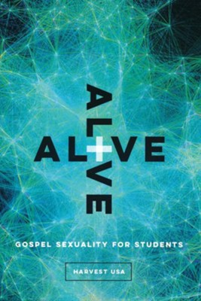
Alive: Gospel Sexuality for Students, Cooper Pinson - In a changing culture where feelings about our identity inform our sexual choices, this ten-week small group resource applies biblical truth in a compassionate way to sexual struggles.

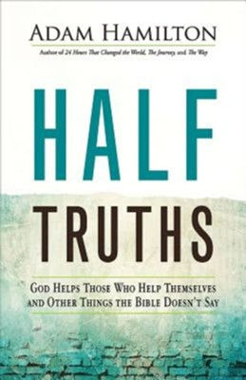
Half Truths: God Helps Those Who Help Themselves and Other Things the Bible Doesn't Say, Adam Hamilton - Join Adam Hamilton in exploring popular sayings that miss the point. They are simple phrases: "God helps those who help themselves," "Love the sinner, hate the sin," and others. They sound Christian - like something you might find in the Bible. We’ve all heard these words. Maybe we’ve said them. They capture some element of truth, yet they miss the point in important ways.
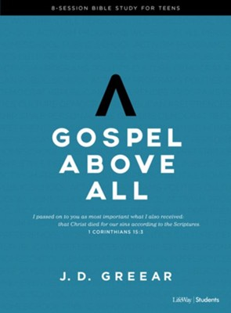
Gospel Above All, J.D. Greear - People may think Christianity is dying, but this pronouncement is a little premature. In this Gospel Above All 8-session Bible Study for teens , J.D. Greear examines what it means for believers to place the gospel above all other priorities in our lives and in our churches.

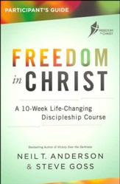
Freedom in Christ, Neil T. Anderson and Steve Goss - The Freedom in Christ Participant's Guide will take you through the 10-session course that can be completed in conjunction with the accompanying video lessons or by a leader using scripts from the Leader's Guide. The course focuses on how to believe, not how to behave and will help you clear away the spiritual cobwebs and connect with Jesus in a deeper way.
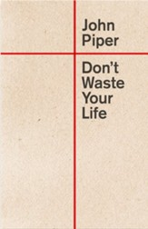
Don’t Waste Your Life, John Piper - Piper has a passionate message for today's generation: Life is short---make yours count! Dare to live for the "great and glorious things that matter"---take risks in relationships for the sake of righteousness, in financial decisions for the cause of the gospel, and in witnessing to the truth and beauty of Christ.
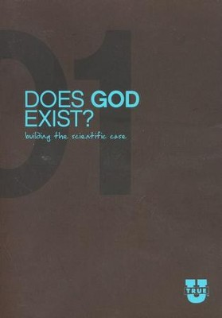
TrueU (series of 3: Does God Exist?, Is the Bible Reliable?, and Who Is Jesus?), Focus on the Family – (Example) TrueU: Who is Jesus? is designed to help students and young adults discover the truth about Jesus - for themselves.

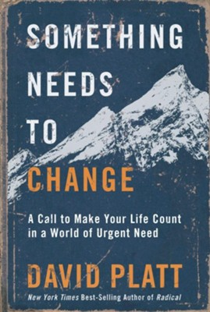
Something Needs to Change: Call to make your life count in a world of urgent need, David Platt - Being confronted with suffering causes us to ask questions that, if we are honest, we would rather ignore. However, if we believe the Bible, ignorance of profound human need is not an option for us.

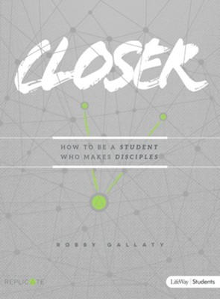
Closer: How to be students who make disciples, Robby Gallaty - Biblically rooted and gospel-centered, Closer: How to Be a Student Who Makes Disciples is an 8-session Bible study for teens that addresses the what, why, where, and how of discipleship. Personal study is to be completed between sessions. At the back of the book are Leader helps with questions and discussions for small groups.
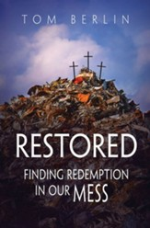
Restored: Finding redemption in our mess, Tom Berlin and Josh Tinley - Based on Tom Berlin's book Restored: Finding Redemption in Our Mess, Josh Tinley takes students in grades 6 to 12 on a journey from their own brokenness to redemption and restoration through Jesus. Everything needed to conduct a six-session study of Restored is included in this Restored Youth Study Book by Josh Tinley.
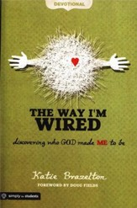
The Way I’m Wired: Discovering who God made me to be, Katie Brazelton - This book is packed with 200 Scripture verses that will fuel your teenagers' hunger for pursuing God's unique plan. They'll explore God's purpose for men and women in the Bible, discovering how God used them powerfully to impact families, communities, and entire nations. Each devotional also features Reflection Questions and Life Purpose.
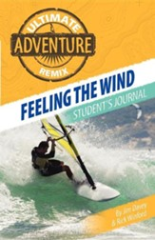
Feeling the Wind, Jim Davey and Rick Winford - The Christian life will bring a lot of changes-changes in your life goals, your values, and your attitudes toward other people. The Holy Spirit provides the power and guidance you need to keep on changing and moving ahead. Jesus promises that his Spirit will carry you along, no matter how rough life may get.
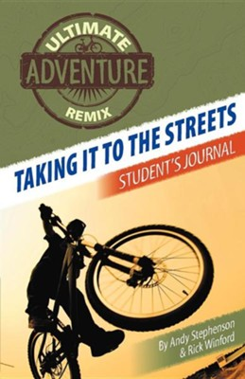
Taking it to the Streets, Andy Stephenson and Rick Winford - The Ultimate Adventure Remix series has led you through several stages of spiritual growth as a Christian. We call this process discipleship. Discipleship isn't just a matter of absorbing the right "head knowledge" about your relationship with Christ. You also need "street smarts"-the knowledge and skills to live your Christian faith every day in your school, your community, and beyond. "Taking It to the Streets" shows you how to do that.
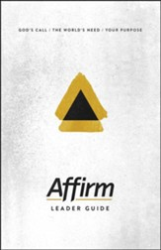
Affirm: God’s Call/The World’s Need/Your Purpose - Affirm is a 6-week discipleship refresh from confirmation. With an emphasis on following Jesus and spiritual practices Affirm is great for a youth group series, a small group study, or for a weekend retreat.

Canvas: A portrait of God - In Canvas: A Portrait of God, students will learn that the Bible is, from beginning to end, the story of God. It's about God's character and his relationship to the world he created. God is with us, suffers alongside of us, is all-powerful, and our closest ally and friend. The four-session study consists of an Immerse Lesson the first week, followed by three more traditional lessons.
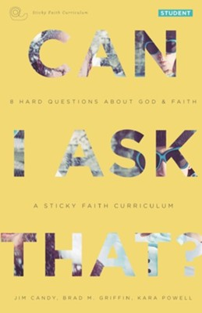
Can I ask that?: 8 Hard questions about God and faith, Jim Candy and Brad M. Griffin and Kara Powell - Ever had a question about God that you were scared to ask? Ever felt like your hard questions get squashed, silenced, or brushed aside? We get that. We wrote this guide for people like you. And we have good news. First, other teenagers and adults ask these kinds of questions all the time. Second, it's not only okay to ask hard questions, but it's actually important-some say essential-for your faith journey. And finally, God can handle it. God isn't anxious about your questions, struggles, or doubts. We don't think you should be either.
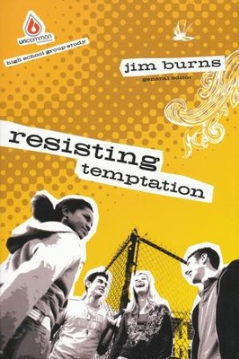
Resisting Temptation, Jim Burns - Between the internet, satellite tv, a sexed-up culture and easy access to drugs and alcohol, many teenagers find it almost impossible to walk the straight and narrow-even though most students in your group want to! Twelve sessions of youth-friendly Bible study will get your teens thinking and talking about avoiding sexually tempting situations, rejecting the false promises of drugs and alcohol and discerning the media's mixed messages.
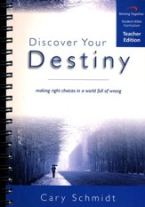
Discover Your Destiny: Making Right Choices in a World Full of Wrong, Cary Schmidt - The ten years between ages seventeen and twenty-seven are when most people make their worst decisions...often irreversible. This 17-lesson study is for Senior High teens and College students making transitions into adulthood. It's designed to guide you step by step through the biblical principles that will help you discover God's plan for your life and to equip you with the tools you need to make the right choices.

All books/study series accessed from https://www.christianbook.com/

